Full Stack Development with MERN Project
Documentation
1. Introduction
• Project Title: BOOK A DOCTOR

Project Overview
- Purpose:
To bridge the gap between patients and healthcare providers by offering a streamlined, digital platform to easily find, schedule, and manage medical appointments, minimizing scheduling conflicts and optimizing clinical workflows.
Features:
- Role-Based Portals: Specialized access controls and custom dashboards tailored for Patients, Doctors, and Administrators.
- Doctor Discovery: Multi-criteria search and filter mechanics allowing patients to view verified providers by specialty, location, and real-time availability.
- Appointment Pipeline: Interactive booking interface with file upload capabilities for medical history, automated status transition tracking, and context-aware notification generation.
- Admin Governance: Centralized workflow for auditing and approving medical registrations to guarantee compliance with regulatory frameworks.

Architecture
The application is constructed using the MERN (MongoDB, Express.js, React, Node.js) stack, strictly following the Model-View-Controller (MVC) architectural pattern to separate data operations, application logic, and routing interfaces.

◦ Frontend: (React.js)
◦ Built with React 18 and Vite as the build tool for fast hot-reload development.
◦ Component-based architecture — reusable Navbar and Protected Route components wrap all pages.
◦ AUTH Context (React Context API) manages global authentication state — user object, JWT token, login and logout functions.
◦ React Router v6 handles client-side navigation with role-based protected routes for Patient, Doctor, and Admin.
◦ Axios utility instance (src/utils/api.js) sets base URL and auto-attaches the JWT token to every outgoing request via an interceptor.
◦ Bootstrap 5 provides responsive grid layout, cards, badges, tables, and form components.
◦ React Toastify delivers non-blocking success and error toast notifications throughout the UI.
◦ Vite proxy configuration forwards all /API/* requests to http://localhost:5000, eliminating CORS issues during development.

◦ Backend: (Node.js+express.js)
◦ Follows the MVC (Model-View-Controller) architectural pattern for clean separation of concerns.
◦ Model Layer — Mongoose schemas define the data structure and validation rules for Users, Doctors, Appointments, and Notifications.
◦ Controller Layer — Five controller files contain all business logic: auth, user, doctor, appointment, and admin controllers.
◦ Route Layer (View) — Five route files map HTTP methods and URL patterns to the correct controller functions.
◦ Middleware Layer — auth.js provides JWT verification (protect) and role-based guards (authorize). upload.js configures Multer for file handling.
◦ Express CORS middleware is configured to accept requests only from http://localhost:5173.
◦ Dotenv loads environment variables (PORT, MONGO_URI, JWT_SECRET) from the .env file at startup.
All uploaded files are saved to server/uploads/ and served statically via /uploads route.

◦ Database: (MongoDB)
◦ MongoDB is used as the NoSQL document database, connected via Mongoose ODM.
◦ Database name: book a Doctor — configured in the MONGO_URI environment variable.
◦ users collection — stores name, email, hashed password, role (patient/doctor/admin), phone, blood group, and is Active flag.
◦ doctors collection — stores specialty, qualifications, experience, fee, hospital, location, available Slots array, approval Status, and a reference to the users collection.
◦ appointments collection — stores patient and doctor references (ObjectId), appointment Date, timeSlot, visitType, reason, status, documents array, doctorNotes, and prescription.
◦ notifications collection — stores recipient reference, message text, type, relatedId, and isRead Boolean.
◦ Passwords are never stored in plain text — bcryptjs hashes them with salt rounds of 12 before saving via a Mongoose pre-save hook.

Setup Instructions
Prerequisites:
- Node.js: version 16.x or superior installed locally.
- Package Manager: npm version 8.x or superior.
- Database Instance: Locally running MongoDB Community Server service (port 27017) or an active MongoDB Atlas cluster cloud deployment string.

- Installation: Installation & Environment Configuration.
1.Open a terminal instance and create the master directory:
mkdir BookADoctor && cd BookADoctor
mkdir client server
- Navigate into the /server directory and initiate dependency resolution:
cd server && npm install
- Establish a backend environment parameters definition record (.env):
PORT=5000
MONGO_URI=mongodb://localhost:27017/bookaDoctor
JWT_SECRET=your_super_secret_jwt_key_here
JWT_EXPIRE=7d
NODE_ENV=development
- Navigate into the /client directory and initialize client-side module compilation:
cd ../client && npm install

Folder Structure
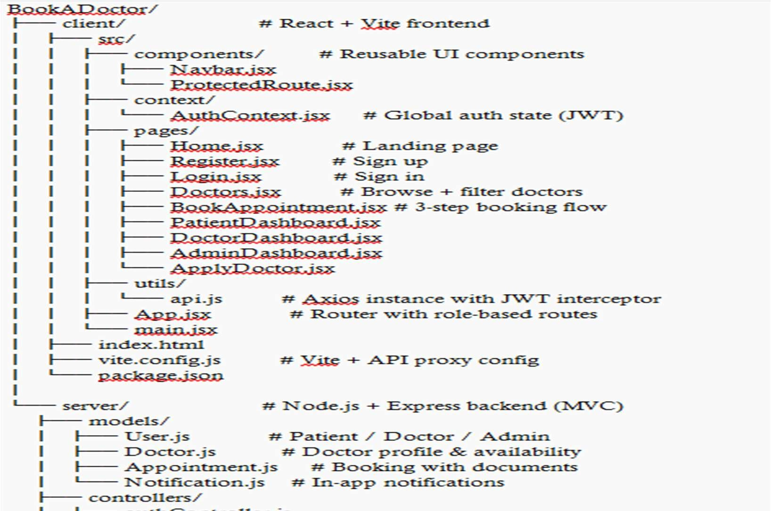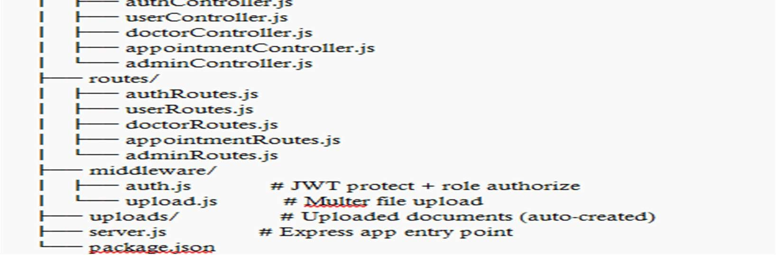
- Client (React Frontend):
File / Folder | Description
src/main.jsx | Entry point — renders App inside  React.StrictMode
src/App.jsx | Root component — all route definitions with role-based protection
src/context/AuthContext.jsx | Global auth state — login, register, logout, and user object

src/utils/api.js | Axios instance with /api base URL and JWT auto-attach interceptor
src/components/Navbar.jsx | Top navigation bar — role-aware links and logout button
src/components/ProtectedRoute.jsx | HOC — redirects unauthenticated or unauthorised users
src/pages/Home.jsx | Public landing page with hero, specialty grid, and features
src/pages/Register.jsx | Sign-up form with name, email, password, and role selector
src/pages/Login.jsx | Login form with role-based redirect after success
src/pages/Doctors.jsx | Doctor listing with specialty filter chips and search bar
src/pages/BookAppointment.jsx | 3-step booking flow with date, details, and document upload
src/pages/PatientDashboard.jsx | Patient home — appointments, notifications, quick actions
src/pages/DoctorDashboard.jsx | Doctor home — confirm, reject, and complete appointments
src/pages/AdminDashboard.jsx | Admin home — stats, pending doctors, and user management
src/pages/ApplyDoctor.jsx | Doctor application form for registered patients
vite.config.js | Vite config — proxies /api/* to http://localhost:5000
index.html | Root HTML shell — mounts the React app via <div id=root>

- Server (Node.js Backend):
File / Folder | Description
server.js | Express entry point — middleware setup, route mounting, DB connect
models/User.js | Mongoose schema — patient, doctor, and admin accounts
models/Doctor.js | Mongoose schema — doctor profile, availability, approval status
models/Appointment.js | Mongoose schema — booking details, documents array, status
models/Notification.js | Mongoose schema — in-app notification records
controllers/authController.js | Register, login, and get current user logic
controllers/doctorController.js | Browse doctors, apply, update profile
controllers/appointmentController.js | Book, view, cancel, confirm, and complete appointments
controllers/adminController.js | Platform stats, approve/reject doctors, user management
controllers/userController.js | Profile update, password change, notifications
routes/authRoutes.js | POST /register, POST /login, GET /me
routes/doctorRoutes.js | GET /, GET /:id, POST /apply, PUT /profile
routes/appointmentRoutes.js | POST /, GET /my, PUT /:id/cancel, PUT  /:id/status
routes/adminRoutes.js | All admin-only endpoints — role-protected
routes/userRoutes.js | Profile, password change, and notification endpoints
middleware/auth.js | JWT protect () and role-based authorize () middleware
middleware/upload.js | Multer config — accepts PDF/JPG/PNG up to 10 MB
. env | Environment variables — PORT,  MONGO_URI, JWT_SECRET (not in Git)

Running the Application
- Backend — open Terminal 1 and run:
cd server npm start
cd client npm run dev
- Frontend — open Terminal 2 (keep Terminal 1 running) and run:
- Expected output:
◦ Backend terminal will show: ✅ MongoDB connected successfully and 🚀 Server running on port 5000
◦ Frontend terminal will show: VITE v5.x.x ready — Local: http://localhost:5173/ ◦ Open http://localhost:5173 in your browser to use the application.
◦ Both servers must run simultaneously — do not close either terminal while testing.
◦ The Vite proxy automatically forwards all /api/* requests to the Express server on port 5000.

API Documentation
- Base URL: http://localhost:5000/api
- All protected endpoints require the header: Authorization: Bearer <JWT_TOKEN>

Authentication Endpoints

Method | Endpoint | Access | Description
POST | /auth/register | Public | Register new user — body: { name, email, password, role } — returns JWT
POST | /auth/login | Public | Login — body: { email, password } — returns JWT + user object
GET | /auth/me | Protected | Returns currently authenticated user details

Doctor Endpoints

Method | Endpoint | Access | Description
GET | /doctors | Public | List all approved doctors — query params: ?specialty=  &search=
GET | /doctors/:id | Public | Get single doctor profile with user info populated
POST | /doctors/apply | Patient | Submit doctor application — body: specialty, hospital, experience, fee
GET | /doctors/my-profile | Doctor | Retrieve own doctor profile
PUT | /doctors/profile | Doctor | Update specialty, fee, availability slots, and bio

Appointment Endpoints

Method | Endpoint | Access | Description
POST | /appointments | Patient | Book appointment — multipart/form-data supports document uploads
GET | /appointments/my | Patient | All appointments for the logged-in patient
PUT | /appointments/:id/cancel | Patient | Cancel a pending or confirmed appointment
GET | /appointments/doctorappointments | Doctor | All appointments assigned to this doctor
PUT | /appointments/:id/status | Doctor | Update status: confirmed / completed / rejected — add notes
GET | /appointments/:id | Both | Single appointment detail with patient and doctor  info

Admin Endpoints

Method | Endpoint | Access | Description
GET | /admin/dashboard | Admin | Platform stats — total users, doctors, pending, appointments
GET | /admin/doctors/pending | Admin | List all doctor applications with status: pending
PUT | /admin/doctors/:id/approve | Admin | Approve doctor — updates approvalStatus and user role to doctor
PUT | /admin/doctors/:id/reject | Admin | Reject application — sends notification to applicant
GET | /admin/users | Admin | All registered users on the platform
PUT | /admin/users/:id/toggle | Admin | Toggle user isActive flag — activate or deactivate account
GET | /admin/appointments | Admin | All appointments across the entire platform

- Example Response — POST /api/auth/login (200 OK):
{
"success": true,
"message": "Login successful",
"token": "eyJhbGciOiJIUzI1NiIsInR5cCI6IkpXVCJ9...",
"user": {“id": "64f8a2b1...", "name": "John Kumar",
"email": "john@email.com", "role": "patient”}
}

Authentication
- Method used: JSON Web Tokens (JWT) — stateless authentication with no serverside sessions.
- How authentication works:
◦ User submits email and password to POST /api/auth/login or POST /api/auth/register.
◦ Server verifies credentials — bcryptjs compares the submitted password with the stored bcrypt hash.
◦ On success, the server signs a JWT using the JWT_SECRET environment variable with a 7-day expiry.
◦ The token is returned in the JSON response and stored in the browser's local Storage by the React client.

- Password Security:
◦ Passwords are hashed using bcryptjs with salt rounds set to 12 before being stored in MongoDB.
◦ The password field is excluded from all query results by default using Mongoose select: false.
◦ Plain-text passwords are never logged or stored anywhere in the system.
- Role-Based Authorization:
◦ Patient — can browse doctors, book appointments, upload documents, and apply to become a doctor.
◦ Doctor — all patient permissions plus confirming, rejecting, and completing their assigned appointments.
◦ Admin — full platform access including doctor approval, user management, and system-wide statistics.
◦ The authorize (...roles) middleware checks req.user.role and returns 403 Forbidden if the role is not permitted.
◦ React Protected Route component also enforces role checks on the frontend to prevent unauthorized navigation

User Interface
- Design System:
◦ Primary colour: Teal (#0B6E6E) — used for navigation, buttons, headings, and section highlights.
◦ Accent colour: Coral (#E8614A) — used for CTA buttons, confirmation actions, and alerts.
◦ Framework: Bootstrap 5 — provides the responsive grid, cards, tables, forms, and badge components.
◦ Typography: Arial throughout — clean, readable, and universally supported.
- Landing Page:
◦ Teal gradient hero section with a tagline, search bar, specialty filter, and a coral Get Started button.
◦ Stats strip showing 500+ Verified Doctors, 50k+ Patients Served, 98% Satisfaction Rate, and 24/7 Support.
◦ 8-specialty browse grid with emoji icons linking to filtered doctor results.
◦ 4-feature highlight cards (Easy Scheduling, Secure Records, Smart Reminders, Verified Doctors).
- Patient Dashboard:
◦ Stat cards showing Upcoming Appointments, Completed Visits, and unread Notification count.
Tabbed interface: Upcoming | Past | Notifications with appointment cards showing doctor, date, and status.
Quick action sidebar with buttons to Find Doctors, Apply as Doctor, and Edit Profile.
- 3-Step Booking Flow:
◦ Step 1 — Date picker showing the next 5 dates + a 12-slot time grid (9 AM to 4:30 PM).
◦ Step 2 — In-Person/Video toggle, reason text area, and multi-file document upload (PDF/JPG/PNG).
◦ Step 3 — Full booking summary table with an Edit button and a coral Confirm Booking button.
◦ Confirmation screen shows appointment details and redirects to the Patient Dashboard.
- Doctor Dashboard:
◦ Appointment stat cards: Pending, Confirmed, Completed, and Total.
◦ Tabbed appointment list with Confirm and Reject buttons on pending appointments.
◦ Visit notes text area and Mark Completed button on confirmed appointments.
- Admin Dashboard:
◦ 5 platform statistic cards at the top of the page.
◦ Pending Doctors tab showing full application cards with Approve and Reject buttons.
◦ Users table with Activate/Deactivate toggle buttons for each account.
◦ Appointments table showing all bookings with patient, doctor, date, type, and status columns.

Testing
- Testing strategy: Manual functional testing, API testing via Postman, and browserbased end-to-end flow verification.
- API Testing with Postman:
◦ POST /api/auth/register — tested with valid data (201 success) and duplicate email (400 error).
◦ POST /api/auth/login — tested with correct credentials (200 + JWT) and wrong password (401 error).
◦ GET /api/doctors — tested with and without specialty/search query parameters.
◦ POST /api/appointments — tested full booking with document upload via multipart/form-data.
◦ PUT /api/appointments/:id/status — tested confirm, reject, and complete transitions by the doctor.
◦ PUT /api/admin/doctors/:id/approve — verified doctor role update and patient notification trigger.
◦ Unauthorized access — verified 401 response when no token is provided on protected routes.
Role enforcement — verified 403 Forbidden when a patient tries to access an admin-only endpoint.
Duplicate slot booking — verified 400 error when a slot is already confirmed or pending.
◦ File size limit — verified 400 error when a file exceeding 10 MB is uploaded.
• Browser Testing:
◦ Complete registration → login → book appointment flow tested on Google Chrome, Firefox, and Edge.
◦ Responsive layout verified at 1920px (desktop), 1024px (tablet), and 375px (mobile) viewports.
◦ Token expiry behaviour — auto-redirect to /login confirmed when a 401 response is received.
◦ File upload tested with PDF, JPG, and PNG formats up to the 10 MB limit.

Screenshots or Demo

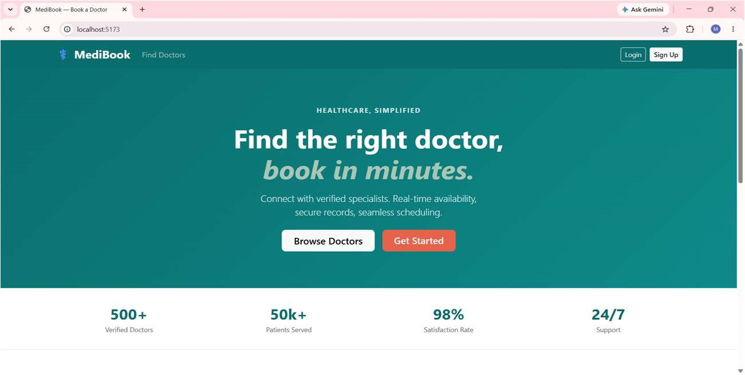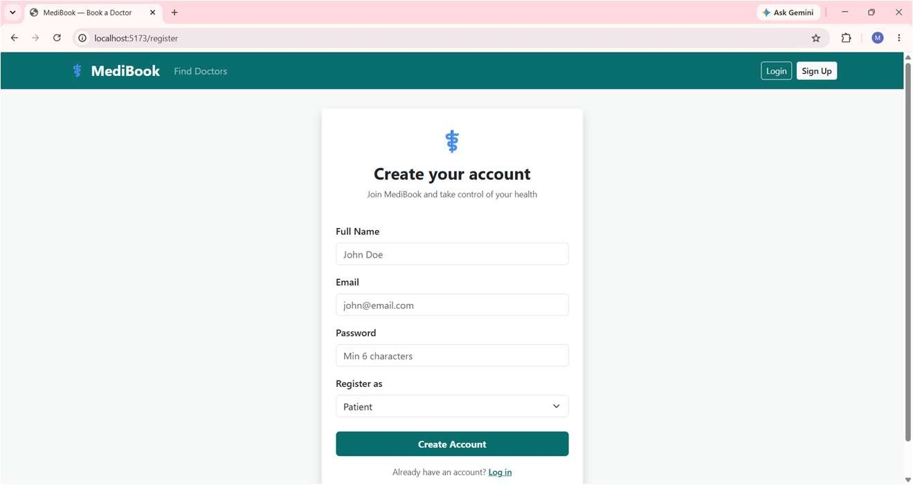

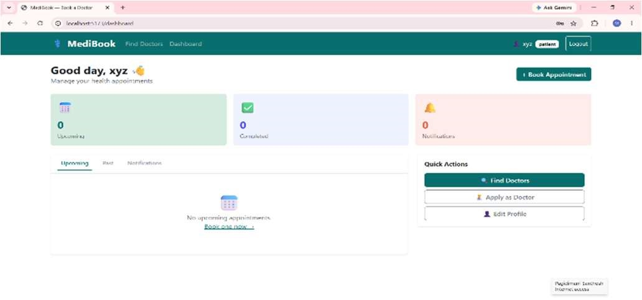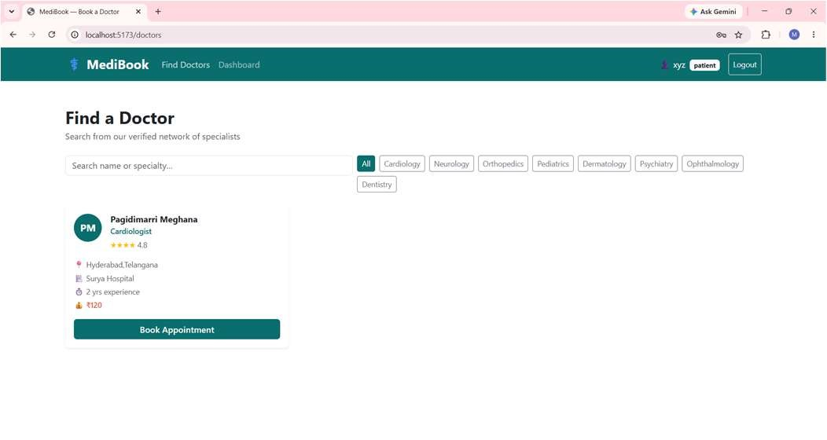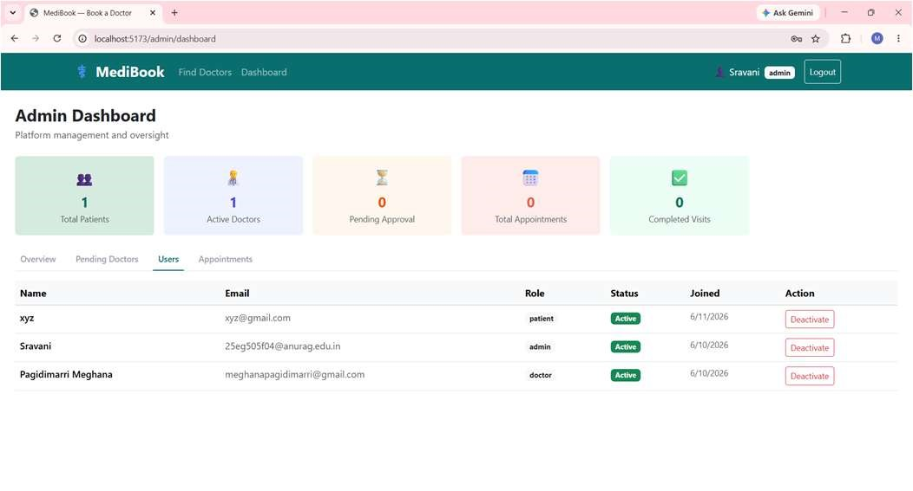

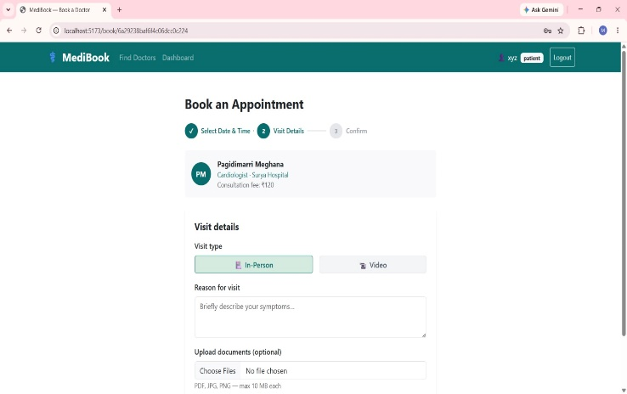 | 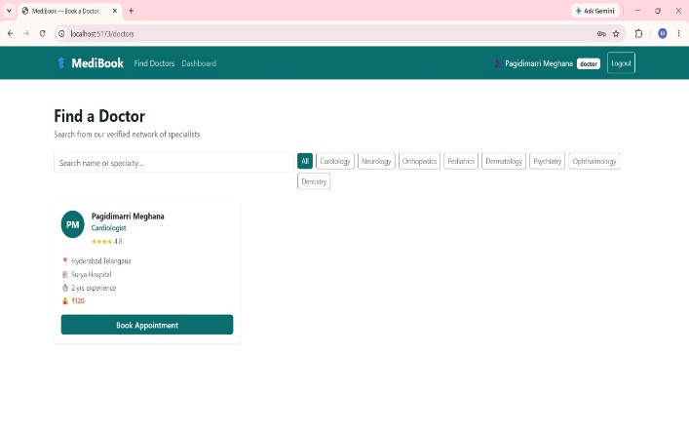
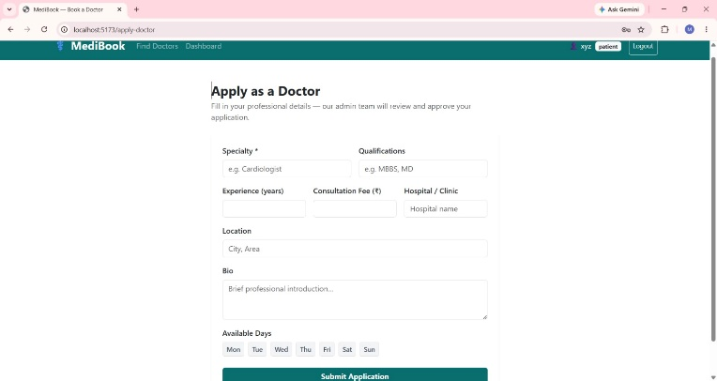

Known Issues
Disk Bloat Vulnerability: Binary data uploads are saved locally directly to /server/uploads/. If deployed inside an ephemeral container network (e.g., free tiers on Render or Heroku), these physical files will be wiped out during automated container cycles, breaking database index references.
Concurrency Vulnerability: The scheduler validates general operational day constraints but lacks synchronous database lock checks during simultaneous multiuser attempts on an identical time block, exposing a minor edge-case double-booking risk under heavy traffic.

Future Enhancements
• The following features and improvements are planned for future versions:

◦ Live Video Consultation — integrate WebRTC or Agora SDK for in-app video calls linked to Video appointment bookings.
◦ Email & SMS Notifications — use Node mailer and Twilio to send real appointment reminders, confirmations, and doctor approval alerts.
◦ Online Payment Integration — add Razor pay (India) or Stripe (international) for consultation fee payment before booking confirmation.
◦ Doctor Ratings & Reviews — allow patients to rate doctors and leave written reviews after completed consultations.
◦ Prescription PDF Export — generate downloadable PDF prescriptions from doctor visit notes using the pdfkit library.
◦ Automated Appointment Reminders — use node-cron to send a reminder notification 24 hours before each scheduled appointment.
◦ Cloud File Storage — migrate uploaded documents from local filesystem to AWS S3 or Cloudinary for scalable, persistent storage.
◦ Advanced Search & Filters — filter doctors by star rating, consultation fee range, available day of the week, and pin code.
◦ Unit & Integration Tests — add a Jest test suite with test coverage for all controllers, middleware, and critical business logic.
◦ Progressive Web App (PWA) — add a service worker and web manifest so the app can be installed on mobile devices and used offline.
◦ Appointment Rescheduling — allow patients to reschedule rather than cancel confirmed appointments, with doctor approval.
◦ Multi-Language Support — add internationalisation (i18n) for Telugu, Hindi, and other regional languages to widen accessibility.

